Instruction Document
Execute the PowerShell Script for Windows Server (Domain Controller and Local Server):
This document contains the instructions to execute the ACTT PowerShell script for Windows, which will read the relevant data from the Windows Server and produce “. actt” files that can be zipped and sent to Deloitte.
The PowerShell script has read only commands and does not modify the server configuration.
Note: We recommend executing the script when there is a minimal load on the server.
Prerequisites for executing the ACTT PowerShell script for Windows:
The “ACTT_WINDOWS_Script.ps1” file is required along with this instruction document. The script auto detects the environment and extracts Active Directory information if the server is Domain Controller (DC)else extracts the Local configuration information if it’s a Local server (NDC).
To execute the script the following privileges are required:
- Administrator Privileges, i.e., Domain Admins (for Domain Controllers).
- Administrator Privileges, i.e., Local Administrator (for Non Domain Controllers/Local Servers).
- PowerShell version on your server needs to be version 4.0 and above.
PowerShell Execution policy needs to be set to RemoteSigned. The below command needs to be run on PowerShell prompt prior to executing the ACTT script on the server and this setting affects only the current Windows PowerShell session.
Set-ExecutionPolicy RemoteSigned -Scope Process
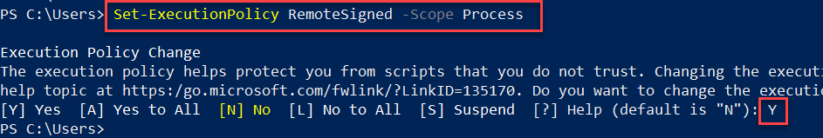
Technical Specifications:
Operating System: | Windows Server 2012/R2 Or 2016 Or 2019
PowerShell Versions: | 4.0 and above
Not Compatible with: | PowerShell versions 3.0 and below
Type of Program/Query: | Windows PowerShell

Steps for executing the PowerShell script (DC and NDC):
- Identify the environment and the type of extraction you need for audit. If you require Active Directory information, please use the script on a Domain Controller (DC) server. If you would like to extract Local server configuration, please use the script on a Local Server (NDC)
- Place the script in an empty folder on the server. Make sure that the server has enough storage space available (Around 2 GB minimum).
- Open PowerShell prompt as ‘Administrator’ Or as a user who has Domain Admin rights and change directory to the folder where the script resides. Run the script with below command.
.\<ScriptName>

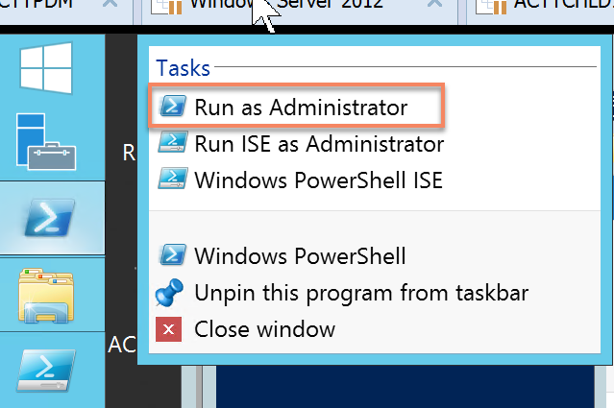

- The script will not prompt for credentials. It will take the credentials of the currently logged in user or the user who had opened the PowerShell prompt. Hence please make sure that you are logged in as a Domain Admin (If running on DC) or as Administrator (If executing on NDC).
- Post extraction you will see a new folder created with extracted files on the same folder where the script was executed. Please Zip the folder and share it with Deloitte contact.

Notice:

The purpose of this “read only” script is to download data that can be analyzed as part of our audit. We expect that you will follow your company’s regular change management policies and procedures prior to running the script.
To the extent permitted by law, regulation and our professional standards, this script is provided “as is,” without any warranty, and the Deloitte Network and its contractors will not be liable for any damages relating to this script or its use. As used herein, “we” and “our” refers to the Deloitte Network entity that provided the script to you, and the “Deloitte Network” refers to Deloitte Touche Tohmatsu Limited (“DTTL”), the member firms of DTTL, and each of their affiliates and related entities.
© 2022. For more information, contact Deloitte Touche Tohmatsu Limited. All rights reserved.

